Exercise-3 Support Vector Machines – Unsupervised learning

**3.1. Kernel Principal Component Analysis:**

Kernel PCA is a dimensionality reduction technique which corresponds to linear PCA in a kernel-induced feature space and is non-linearly related to the original input space. Thus, nonlinearities can be included via the kernel function and the corresponding problem keeps the form of an eigenvalue problem (like linear PCA). Kernel PCA can be used for feature extraction, denoising, dimensionality reduction and density estimation.

We focus here on this toy dataset to get insight in the number of components, the choice of the kernel and the kernel hyperparameter. Linear PCA is used to reveal the internal structure of the data in a way that best explains the variance in the data. If a multivariate data set is visualized as a set of coordinates in a high-dimensional data space (1 axis per variable), PCA can supply the user with a lower-dimensional picture, a projection of this object when viewed from its most informative viewpoint. This is done by using only the first few principal components so that the dimensionality of the transformed data is reduced.

Therefore, truncating the data to a lower number of principal components (lower than the number of the input dimensions) will ‘summarize’ the variance present in the data set. For kernel PCA, the originally linear operations of PCA are performed in a reproducing kernel Hilbert space. The original input space is mapped to a high dimensional features space (*N-*dimensional feature space, where *N* is the number of observations). Therefore, the number of principal components obtained in kernel PCA is higher than in the linear PCA. The difference between both is that in the case of the kernel PCA, the dimension reduction is applied on the kernel matrix (covariance matrix of the data after being transformed into a higher-dimensional space), while in linear PCA, it is applied to the covariance matrix. In linear PCA, the number of principal components is limited to the number of dimensions of the original data. Figure 1 depicts the results of denoising on the toy data set for varying number of components.

Obviously, the more components are kept, the closer the denoised data set will be from the original data set (with noise Noise is assumed to be small compared to the variance of the data. Therefore, choosing a threshold (for example 95%) based on which we retain the number of components reaching this threshold in terms of variance is a possibility. Another possibility is to use the concept of scree plot. A scree plot displays the eigenvalues associated with a component in descending order versus the number of the component. The ideal pattern in a scree plot is a steep curve, followed by a bend and then a flat or horizontal line. The idea is then to retain those components in the steep curve before the first point that starts a flat line trend. To tune the hyper-parameter, one can apply cross-validation based on reconstruction error.







**Fig-1.Plot for denoising deigits with different number of principal components (1,2,4,10)**

**Handdigits recognition:**

The **digitsdn** script is an example of noise reduction. Noise reduction is the process of removing noise from a signal (here from handwritten digit images). The Figure 2 shows the results of reconstructing pre-images from noisy images, by applying kernel PCA or linear PCA. Model is first trained on a sample without noise, and then applied on noisy images. As mentioned in the previous section, kernel PCA is a non-linear generalization of PCA using kernel functions.

Let

{**x***j* ∈ R*m, whereas j* = 1*, ..., n*} be a data set.

To state the result, the principal components are given by,

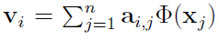

**v***i* = P*nj*=1 **a***i,j*_(**x***j*), where **a***i* are the eigenvectors of the kernel 2 matrix *K*, given by *Kij* = *k*(**x***i,* **x***j*), sorted in order of decreasing corresponding eigenvalue.

To project onto the principal components, a projection **Pq** is defined by **Pq**_(**x**) =X*qj*=1

*_i***v***i,* (1)where *_i* = **v***i* · _(**x**) are the projections of _(**x** onto the principal components. Denoising requires optimal reconstruction **Pq**_(**x** in input space R*m*. The idea is to find an approximate pre-image **˜x** in input space that will map closest to the projection **Pq**_(**x**) in feature space:

**˜x** = arg min

**x**02R*n*

k _(**x**0) − **Pq**_(**x**) k2 (2)

We can see in Figure 2 that the quality of the denoising increases with the number of principalcomponents. It is also clear that kernel PCA performs much better than linear PCA.



**Fig-2.Plot for denoising deigits with Kernel PCA (left) vs Linear PCA**

**3.3 Spectral Clustering**

In multivariate statistics and the clustering of data, spectral clustering techniques make use of the spectrum (eigenvalues) of the similarity matrix of the data to perform dimensionality reduction before clustering in fewer dimensions. Spectral clustering techniques make use of the eigenvectors of a Laplacian matrix derived from the data to create groups of data points that are similar. In this context, the kernel function acts as a similarity measure between two data points. The Laplacian matrix is then obtained by re-scaling the kernel matrix.

We run the script *sclusteringscript* and obtain the following figures:





**Fig-3. Plots for Sigma factor 0.001**



**Fig-3. Plots for Sigma factor 0.001**





**Fig-4. Plots for Sigma factor 0.005**





**Fig-5. Plots for Sigma factor 0.01**





**Fig-6. Plots for Sigma factor 0.2**

The difference with classification is that clustering is an unsupervised learning technique (no labels available). The different with standard clustering is that, as mentioned above, spectral clustering makes use of the eigenvectors of a similarity matrix instead of the similarity matrix itself (k-means for example).

In spectral clustering with RBF kernel, *_* denotes the bandwidth of the kernel. As in other kernel applications, the tuning of the parameters of the kernel is an important component to the performance of the model. A cross-validation approach can be used here.

First, a grid of possible values of the tuning parameters is constructed. Afterwards, a model is trained for each combination of parameters and a chosen criterion is evaluated on the partitioning predicted for the validation data. Finally, the parameters yielding the maximum value of the criterion are selected. In the kernel, spectral clustering, a criterion based on the amount of collinearity between validation points belonging to the same cluster, in the space of the projections performs well. It reaches its maximum value 1 in the case of well-separated clusters.

**3.4.Fixed-Size LS-SVM**

The LS-SVM formulation solves a linear system under a least squares cost function. Although the LS-SVM dual formulation is quite advantageous when working with large dimensional input spaces, or when the dimension of the input space is larger than the sample size, it requires the resolution of a linear system with as many unknowns as the number of data points, N. This situation has an obvious drawback when N is too large, and in such case the direct application of this method becomes prohibitive. However, the primal-dual structure of the LS-SVM can be exploited further. It is possible to compute an approximation of the nonlinear mapping *_* to perform the estimations directly in primal space; furthermore, it is possible to compute a sparse approximation by using only a subsample of selected Support Vectors from the dataset. Explicit expressions for *_* can be obtained by means of an eigenvalue decomposition of the kernel matrix.

The approximation of the feature space is based on a fixed subset of data points. One way to select this fixed-size set is to optimise the entropy criterion of the subset. As an example, we run the *fixedsizescript*1 script and obtain the Figure 13. The script chooses an optimal subset of points to be used for fixed size ls-svm according to the quadratic Renyi entropy for a kernel-based estimator. The script is run for a specific value of the hyperparameter of the RBF kernel (*_*2 = 1). Figure 14 compares the same results for varying *_*2 (0.01, 0.1, 0.5, 10).



**Fig-7.2. Plots for Sigma2 0.1**



**Fig-7.1. Plots for Sigma2 0.05**



**Fig-7.4. Plots for Sigma2 5.0**



**Fig-7.3. Plots for Sigma2 1.0**



**Fig-7.5. Plots for Sigma2 10.0**

We clearly see that the hyper-parameter σ2 has an influence on chosen (optimal points) as follows;

* As σ 2 increases, the optimal support vectors are more spread across the entire cloud of points and less concentrated in the centre.
* For higher values of σ 2, the chosen points are more situated at the boundaries of the cloud defined by all points.

Kernel density estimation is a non-parametric way to estimate the probability density function of a random variable (here, RBF kernel is used). For fixed size ls-svm, the selection of a subsample of size *M* (*M* has here chosen arbitrarily), the initial support vectors, is done prior to the estimation of the model, and the final performance of the model can depend on the quality of the initial selection. It is possible to take a random selection of *M* data points and use them to build the approximation of the nonlinear mapping , or it is possible to use a more optimal selection. External criteria such as entropy maximisation can be applied for an optimal selection of the subsample. In this case, given a fixed-size *M*, the aim is to select the support vectors that maximise the quadratic Renyi entropy.

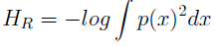

that can be approximated by,

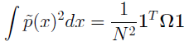

Whereis the kernel matrix.

Starting from a random sample of size *M*, it is possible to replace elements of the selected sample by elements of the remaining sample if the entropy is minimised, and iterate this procedure until convergence. In this way, it is possible to obtain a selection of those *M* points that converge to a minimum value of the quadratic entropy.

Therefore, the algorithm used in the *fixedsizescript*1 script converges to the points that ‘summarises’ the best the kernel density estimation (i.e. have the highest probability in the KDE). It is important to choose an appropriate value of the hyperparameter. This can be done using cross-validation based on quadratic Renyi entropy.

Given this optimised subset, the feature space mapping can be reconstructed. Figure 8 shows an example of such reconstruction for a random variable of dimension for which three points have been extracted.



**Fig-8. Original and Feature space**

A drawback of LS-SVM models is the lack of sparseness, as nearly all patterns become support vectors. A solution to this problem is To use *L*0-norm. The *L*0-norm counts the number of non-zero elements of a vector. Therefore, minimising it leads to very sparse models. Figure 16 compares Fixed-Size LS-SVM with the *L*0 approximation LS-SVM.

Comparison of FS LS-SVM and *L*0 approximation LS-SVM:





**Fig-9. FS-LSSVM vs SV_L0_nom Comparison**

The performance (in terms of error) of *L*0 approximation is comparable to the Fixed-Size LS-SVM. This is very good, as the number of support vectors is generally much lower than the Fixed-Size case. The computing time is comparable to both models but obviously much lower than the LS-SVM case.

**3.5 Homework Problems:**

**3.5.1 Handwritten Digit Denoising**

This work demonstrates how we can use the kernel methods for denoising the handwritten digits with varying details of different parameters. Usually, a rule of thumb for σ2 has calculated as the mean of the variances of each dimension times the dimension (number of features) of the training data. The σ2 hyper-parameter plays a major role in the performance of the denoising and should be tuned for meeting the desired performances. When we change the value of σ2 to a much bigger value compared to the previous rule of thumb with an increase in the noise factor, we obtain various results which all are presented below. We also observe that if the value if the value of σ2 is too high, denoising with kernel PCA deteriorates. As noise is associated with darker colours, higher values of σ2 imply that each point will be influenced by more adjacent points in the denoising process. Therefore, higher values of σ2 lead to a less efficient denoising algorithm which can be seen below.

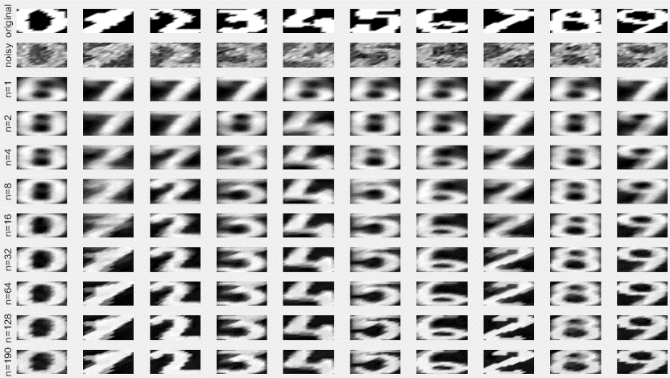

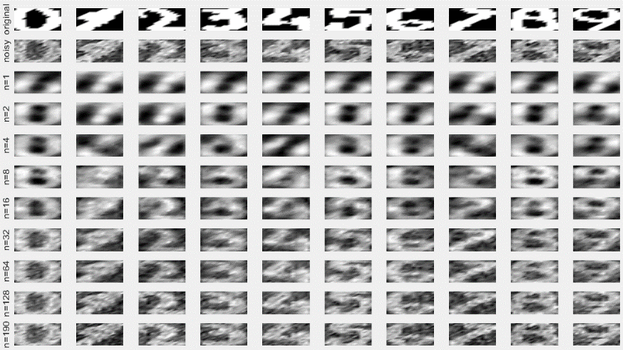

**Fig-10.1 Denoising based on Kernel PCA and Linear PCA with sigma2=0.7 and noise factor 0.3**

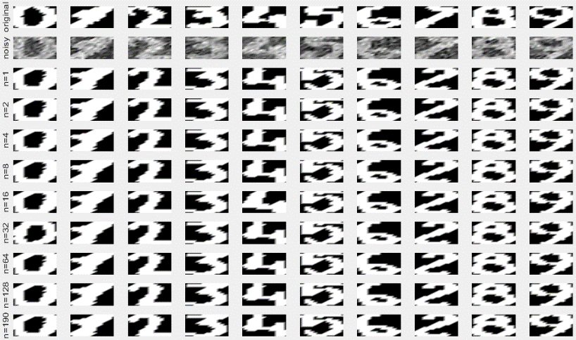

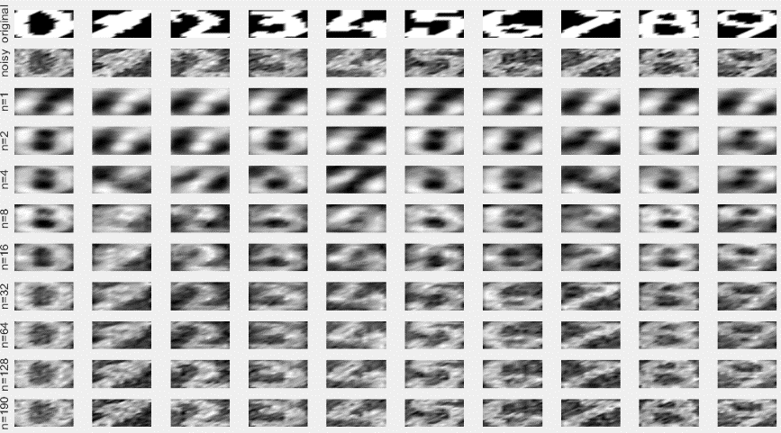

**Fig-10.2 Denoising based on Kernel PCA and Linear PCA with sigma2=0.01 and noise factor 0.3**

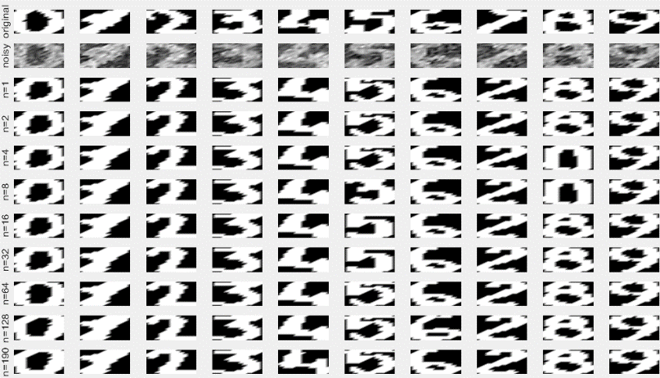

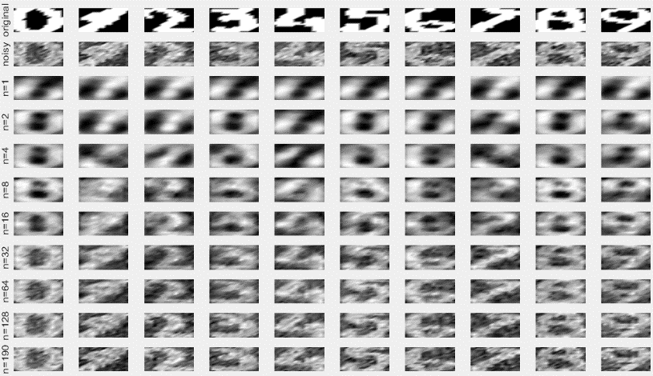

Sigma2=1

noisefactor=0.3

**Fig-10.3 Denoising based on Kernel PCA and Linear PCA with sigma2=1 and noise factor 0.3**

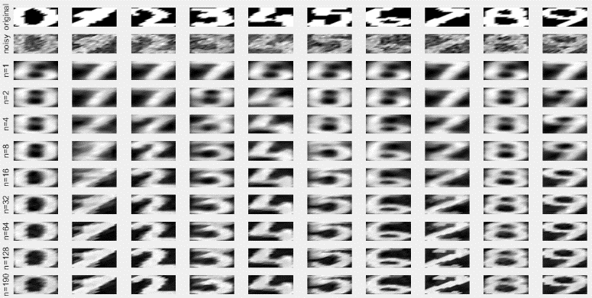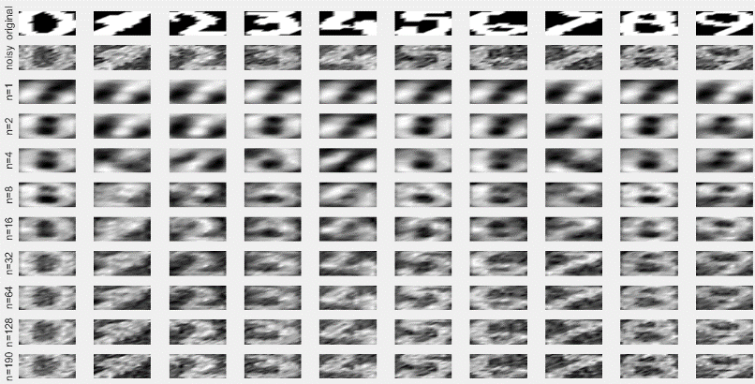

**Fig-10.3 Denoising based on Kernel PCA and Linear PCA with sigma2=1 and noise factor 0.3**

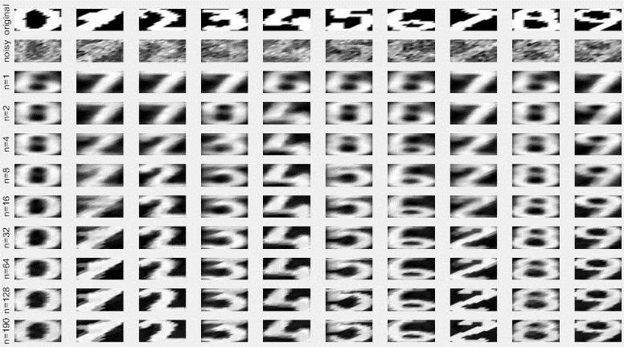

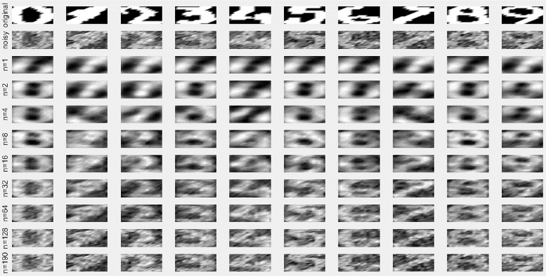

**Fig-10.3 Denoising based on Kernel PCA and Linear PCA with sigma2=0.7 and noise factor 0.4**

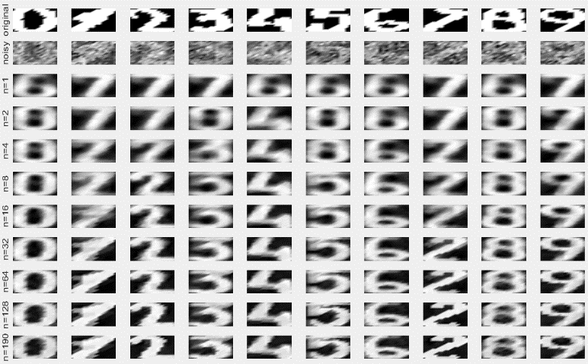

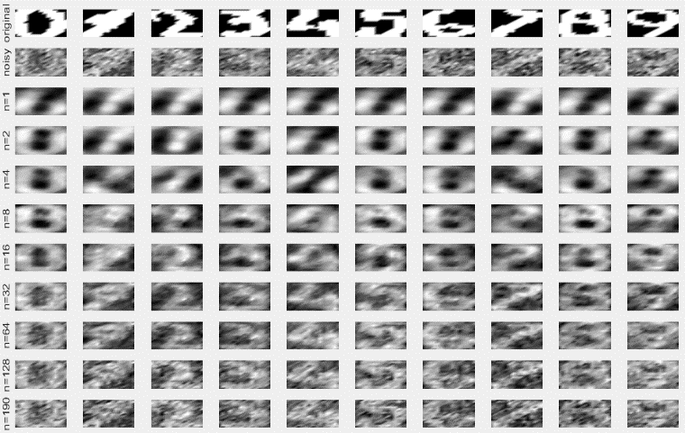

**Fig-10.3 Denoising based on Kernel PCA and Linear PCA with sigma2=0.7 and noise factor 0.5**

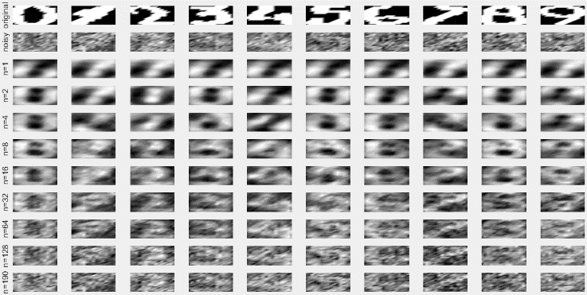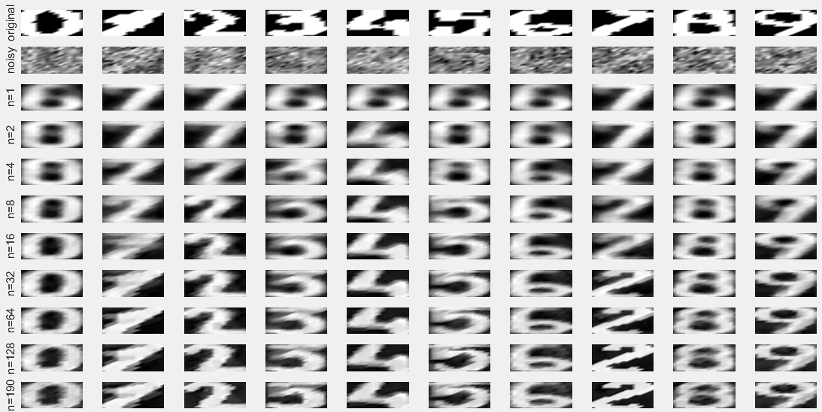

**Fig-10.3 Denoising based on Kernel PCA and Linear PCA with sigma2=0.7 and noise factor 0.7**

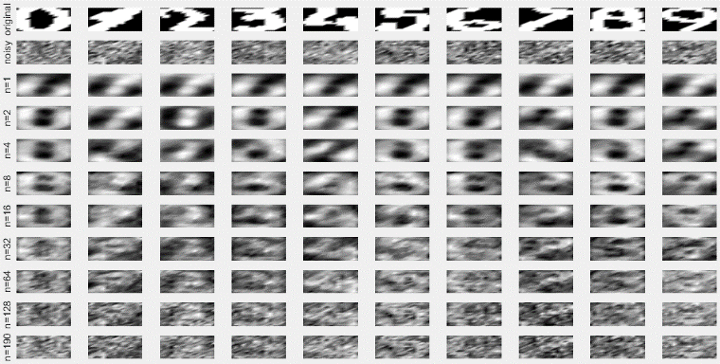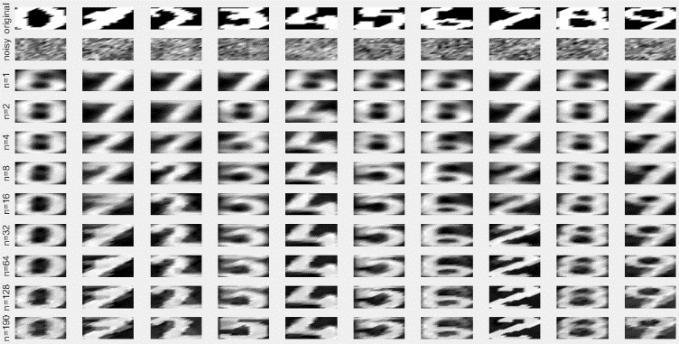

**Fig-10.3 Denoising based on Kernel PCA and Linear PCA with sigma2=0.7 and noise factor 0.9**



**Fig-11 Reconstruction error as a function of sigma factor**

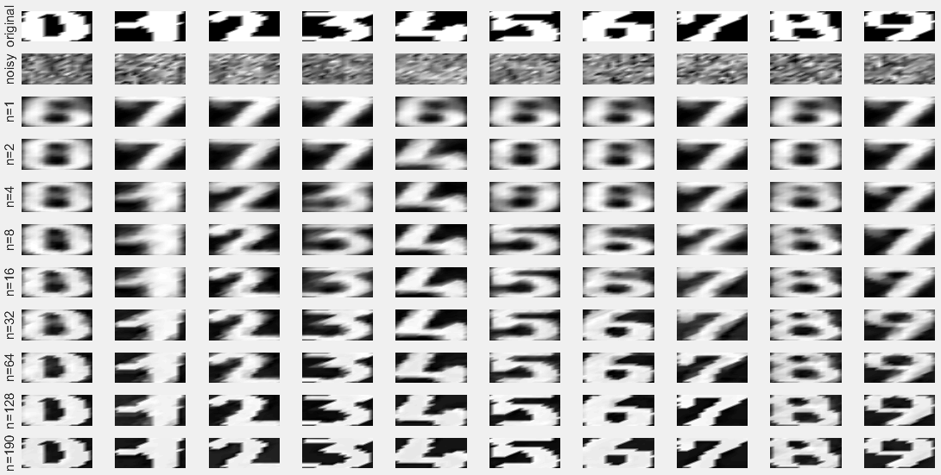

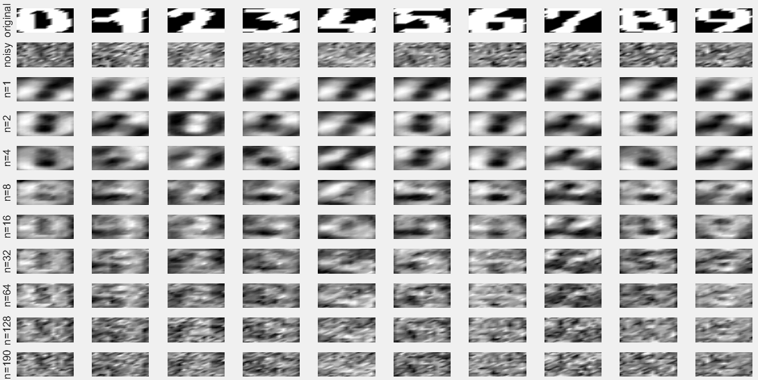

We chose σ *factor* that minimised the reconstruction error on the validation set (Xtest1). The exact value minimising reconstruction error depends on the number of principal components we keep for the denoising. However, we can observe from these Figures that the reconstruction error is always minimised around a σ *factor* value of 0.5. Therefore, we use this same σ *factor* on the test set(Xtest2).We observe that again, kernel PCA (left) gives much better results than linear PCA.

California Dataset:

**Fig-12 Plot for denoising on the test set using Kernel PCA**

**Fig-13 Plot for denoising on the test for using Linear PCA**

**3.5.3 California Dataset:**

The fslssvm script is adjusted to be used with California dataset with given number of following features and apply regression. With different types of kernels, the comparison has been made between FS-LSSVM and SV_L0_norm.

Polynomial plots: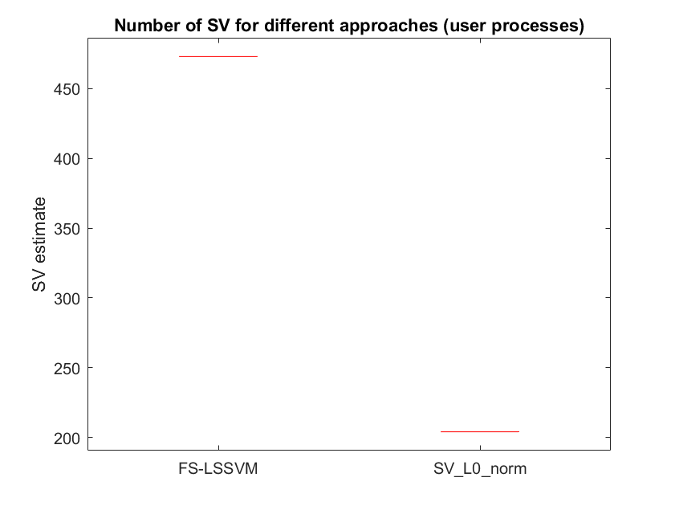

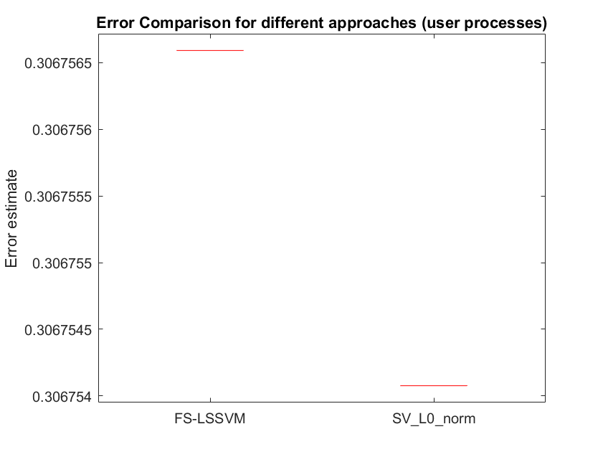

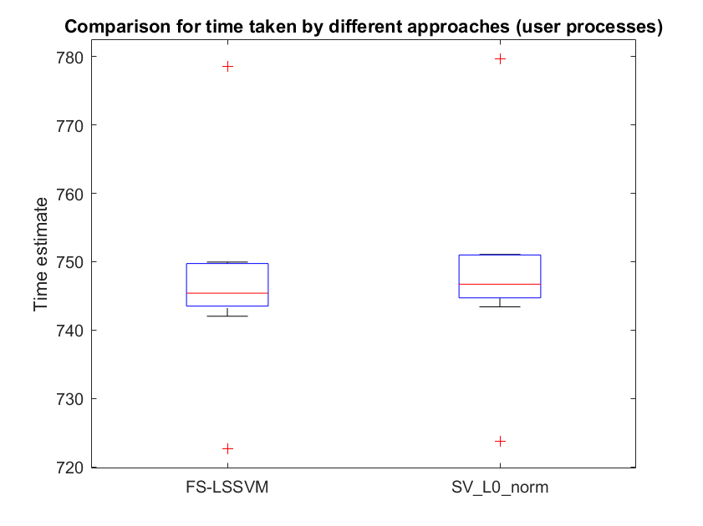

**Fig-14 Plots for Comparison on California dataset denoising on the test for using Linear PCA**

Using RBF kernel:





**Fig-15 Plots for Comparison on California dataset using RBF Kernel**